Online Tutoring and Skill Marketing


SUBMITTED BY
Laika Iftikhar (24915)
BS Computer Science Session 2024-2028
SUPERVISED By
Asst. Prof. FAISAL
DEPARTMENT OF COMPUTER SCIENCE
GOVERNMENT ISLAMIA GRADUATE COLLEGE, KASUR
1

Online tutoring and skills marketing
Laika Iftikhar (24915)
Department of Computer
University of Punjab April 2028
This thesis is submitted in partial fulfillment of the
Requirement of Computer Science, Government Islamia Graduate College, Kasur.
2

DEDICATION
With deepest gratitude, I honor my parents, whose love, wisdom and unwavering support have been the driving force behind my academic journey. Their guidance, encouragement, and sacrifices have shaped me into the individual I am today. I am forever thankful for their presence in my life.

3

DECLARATION
I hereby declare that this documentation is my own work and that, to the best of my knowledge and belief, it contains no material previously published or written by another person, nor material which to a substantial extent has been accepted for the award of any other degree or diploma of any university or other institution, except where due acknowledgment is made in the text. I also declare that the intellectual content of this documentation is the product of my own work, except to the extent that assistance from others in the project’s design and conception or in style, presentation, and linguistic expression is acknowledged.
The work presented in this thesis was carried out by me under the supervision of Assistant Prof. Faisal, Department of Computer Science, Government Islamia Graduate College, Kasur. These conclusions are my own research after numerous discussions with my supervisor. I have not presented any part of this work to any other degree. Furthermore, I acknowledge that any assistance received in preparing this thesis and the sources from which such assistance was derived are acknowledged within the thesis itself. I certify that to the best of my knowledge above statement is correct.
Laika Iftikhar

4

ACKNOWLEDGEMENTS
I am eternally grateful to Almighty ALLAH for bestowing upon me the strength, potential, and capability to accomplish my research work. I am proud to be an apostle of the world’s greatest personality, Holy Prophet Muhammad (PBUH), who is mankind’s only full and absolute personality.
I am grateful to Prof. Faisal Head of the Department of Computer Science, for his knowledge and teaching experience. I want to thank him for his thoughtful and positive attitude. I am also thankful to Lect. Muhammad Shabbir for their guidance and knowledge throughout the duration of the coursework and research work. This research, which is neither simple nor straightforward, has provided me with the opportunity to interact with many academically minded individuals and gain valuable life experience. I would want to convey my heartfelt gratitude to my renowned supervisor, Sir Faisal, who helped me in various ways to complete my task. It would have been difficult to finish without his involvement and aid. My heartfelt gratitude goes to my family. This job will never be finished without the prayers, support, and courage of my esteemed parents and close brother. May Allah shower him with His innumerable blessings.
5

iii

CERTIFICATION
This is to certify that the thesis titled ‘Online Tutoring And Skills Marketing’ authored by Laika Iftikhar has been completed in accordance with the requirements for the BS in Computer Science.
I hereby confirm the following:
- The thesis represents the original work of the author.
- Any assistance received in the preparation of this thesis has been duty ac-knowledge.
- All sources used in this thesis have been properly cited and referenced.
- No part of this thesis has been previously submitted for any other academic qualification.
- The content of this thesis does not infringe upon any proprietary rights, including copyright or trademark.
This certification is issued upon the successful completion and examination of the thesis, meeting the academic standards set forth by the Computer Science Department.
Supervisor:  Internal Examiner:  Internal Examiner:  External Examiner: |  |  | Dated:  Dated:  Dated:  Dated:
HOD: Dated:

Contents
1: INTRODUCTION ................................................................................................................ 7
Purpose ................................................................................................................................ 8
Scope ................................................................................................................................... 8
Overview .............................................................................................................................. 8
Definitions, acronyms and abbreviations ............................................................................... 8
2: general description ........................................................................................................... 9
User Characteristics ............................................................................................................. 9
Assumptions and Dependencies ......................................................................................... 10
3: specific requirements ...................................................................................................... 10
Non-Functional Requirement .............................................................................................. 11
Reliability ........................................................................................................................... 11
Availability .......................................................................................................................... 11
Security .............................................................................................................................. 12
Maintainability .................................................................................................................... 12
Backend: ............................................................................................................................ 12
Development Language and Database ................................................................................. 12
Process Model .................................................................................................................... 13

1: INTRODUCTION
The following section of SRS provides an overview of the entire SRS.

1.1 Purpose
The purpose of this system is to develop an online platform where students can learn from qualified tutors and users can offer their professional skills such as graphic designing, programming, language learning, digital marketing, and other services. This platform will connect tutors and learners efficiently.

1.2 Scope
The system will be web-based and mobile-friendly. Users will be able to register, browse courses, hire tutors, attend live classes, make payments, and give reviews.

1.3 Overview
The platform will have three main users:
- Students (Learners)
- Tutors (Skill Providers)
- Admin

1.4 Definitions, acronyms and abbreviations
Term | Meaning
SRS | Software requirements specification
UI | User interface
DB | Database
ADMIN | System administrator
USER | Student /tutor

2: general description

2.1 Software Interface
- Web Browsers (Chrome, Firefox, Edge)
- Mobile Devices
- Payment Gateway
- Video Calling API (Zoom / Google Meet / imo)

2.2 Product Function

- User Registration/Login
- Tutor Profile Creation
- Course Uploading
- Search Tutors
- Book Sessions
- Live Classes
- Secure Payments
- Chat System
- Ratings and Reviews
10.Admin Dashboard

2.3 User Characteristics

2.3.1 Student:
- Basic computer and internet knowledge
- Can enroll in courses
- Can hire tutors
2.3.2 Tutor:
- Subject expertise require.
- Can create profile and set pricing.

2.3.3 Admin:

- Technical knowledge required

- Manages the whole system

2.4 Assumptions and Dependencies

- Internet connection is required

- Payment gateway must be available

- Server should remain active

2.5 Supported browser is required

3: specific requirements

3.1Functional Requirement
3.1.1User Requirements:

- Register Account as Students
- Login /Logout
- Search Account
- Book Sessions
- Making Payment
- Submit

3.1.2 Tutors Requirements:

- Register as Tutors
- Add Skills
- Set timing and fees
- Accept or reject booking 5. Conduct classes

3.1.3 Admin Requirements:

- User Management
- Train Tutors
- Handle complaints and reports
- Manage Payments
- Create Reports

3.2 Non-Functional Requirement

- Fast response time
- Easy to use interface
- Secure transactions
- Scalable system
- High performance

3.3 Reliability

- System should run smoothly 24/7
- No data loss
- Automatic backup available
- Error recovery system available

3.4 Availability

- Platform available 24/7
- 99% uptime
- Maintenance notifications provided

3.5 Security
- Secure login system
- Password encryption
- SSL certificate
- Payment security
- Admin authorization
- User data privacy

3.6 Maintainability

3.6.1 Frontend:

- HTML
- CSS
- JavaScript
- React.js


3.6.2 Backend:


- Node.js/PHP/Laravel
- APIs:
- Zoom API
- Payment API

3.7 Development Language and Database

3.7.1 Languages:

- JavaScript
- PHP
- Python(optional)

3.7.2 Database:

- MySQL
- PostgreSQL

3.8 Process Model
Agile process model is perfect for this documentation. Because this model is frequently changed according to requirements such as new courses, features and user needs.
Agile models work in small iteration like
You must build a small part ->test it ->get feedback ->Improve -> repeat.
New features (chat, video classes, payment system) can be added step by step. Tutor’s and student feedback can be implemented quickly. Bugs and improvements are handled fast.
So, agile model is best for this documentation.

Use Case Diagram
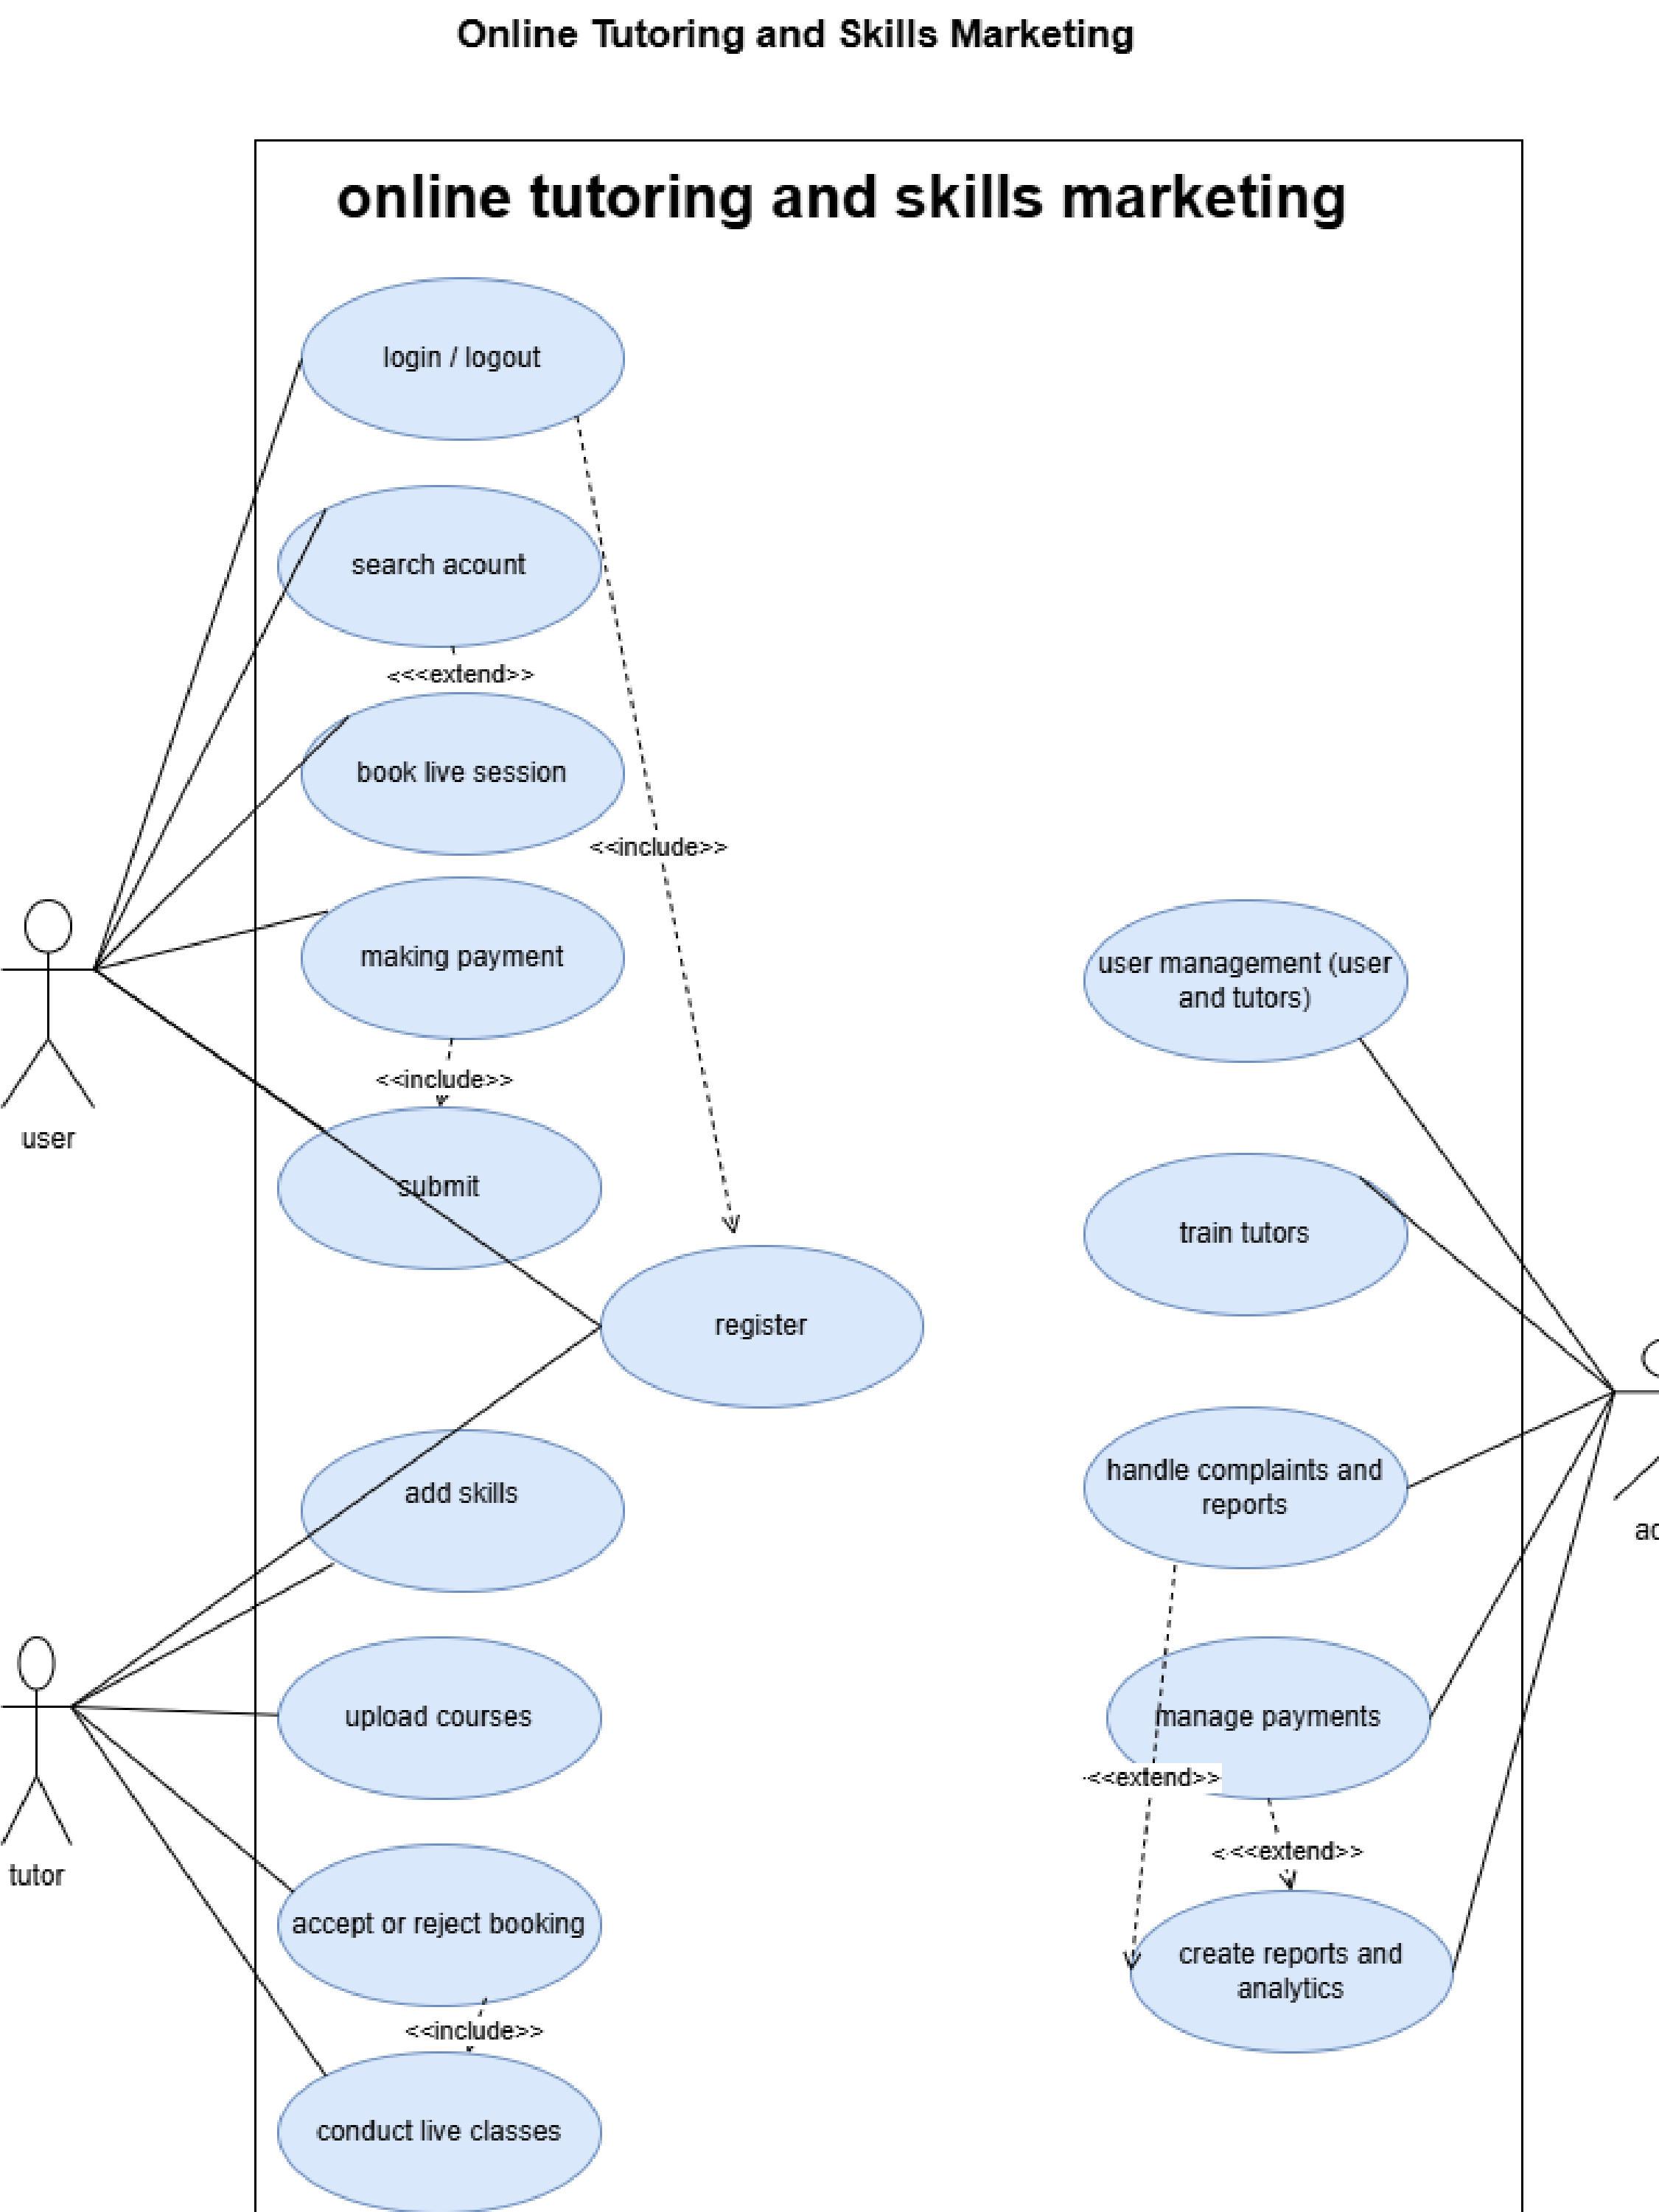

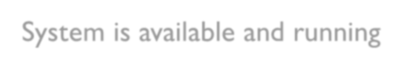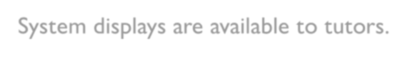

Book Session System

Search Tutor

Actor:

User

Preconditions:

User has internet access

System is available and running

Trigger:

Users want

to find a tutor for a specific skill or course.

Flow of Events:

User opens
an

online tutoring platform.

User enters the required skill/course name.

System displays
are available to

tutors.

User views tutor profiles, ratings, and pricing.

User selects a suitable tutor.

Guarantee:

Tutor search results are displayed successfully.

Users

can proceed
with

booking or enrollment.

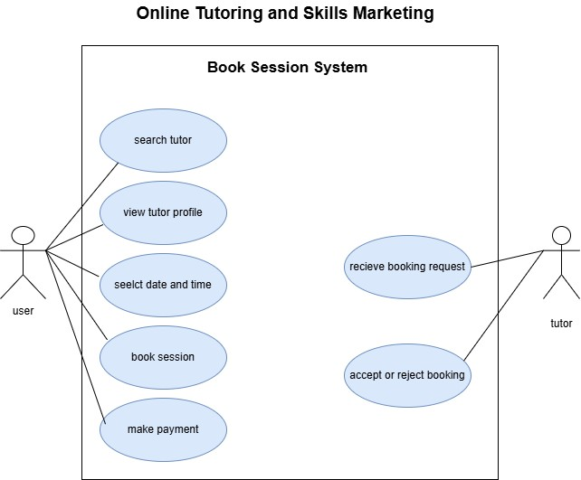


Live Class System

Actors

User

Tutor


Preconditions

Users

and
tutors

must be registered and logged into the system.

Stable internet connection must be available.

Live class schedule must already exist.

Users

must have permission to access the class.

Flow of Events

1
. Tutor starts the live class.

2
. User joins the live class.

3
. Tutor conducts the lecture.

4
. Tutor shares
screens

or study material.

. User communicates through chat during the class.
5

. User views the course material.
6

7
. Live class session ends after completion.

Guarantee (Postconditions)

User successfully attends the live class.

Shared lecture material becomes available to users.

Chat communication is completed successfully.

System stores attendance and session details

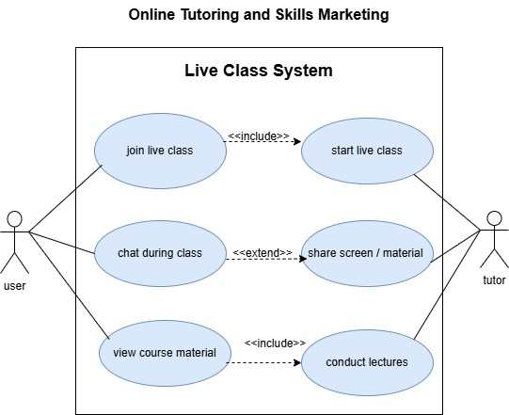

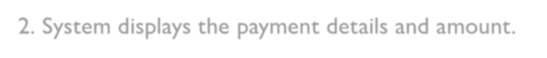
Payment Management System

Actors

User

Tutor

Payment Gateway/System

Preconditions

Users

and
tutors

must be registered and logged into the system.

A session or course booking must already exist.

User must have a valid payment method.

Internet connection must be available.

Flow of Events

1
. User selects the payment option.

2
. System displays the payment details and amount.

3
. User enters payment information.

. Payment request is sent to the payment gateway.
4

5
. Payment gateway verifies the transaction.

6
. Payment is either approved or rejected.

7
. If approved, the system updates the payment status.

8
. User and tutor receive payment confirmation.

Guarantee (Postconditions)

Payment transaction is securely completed and recorded.

User receives payment confirmation or receipt.

Tutor is notified about the successful payment.

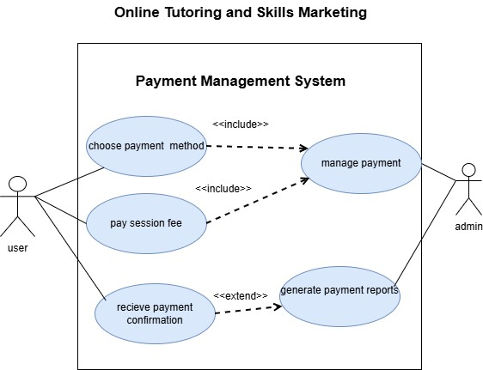
System updates booking or course access after successful payment.

If payment fails, the transaction is cancelled and no charges are applied.

Sequence Diagram
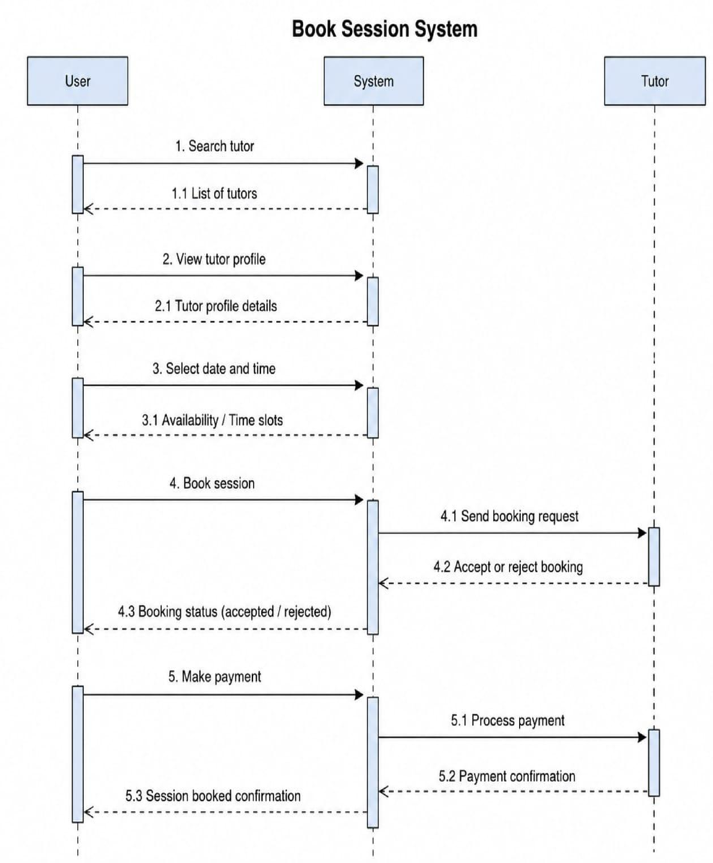
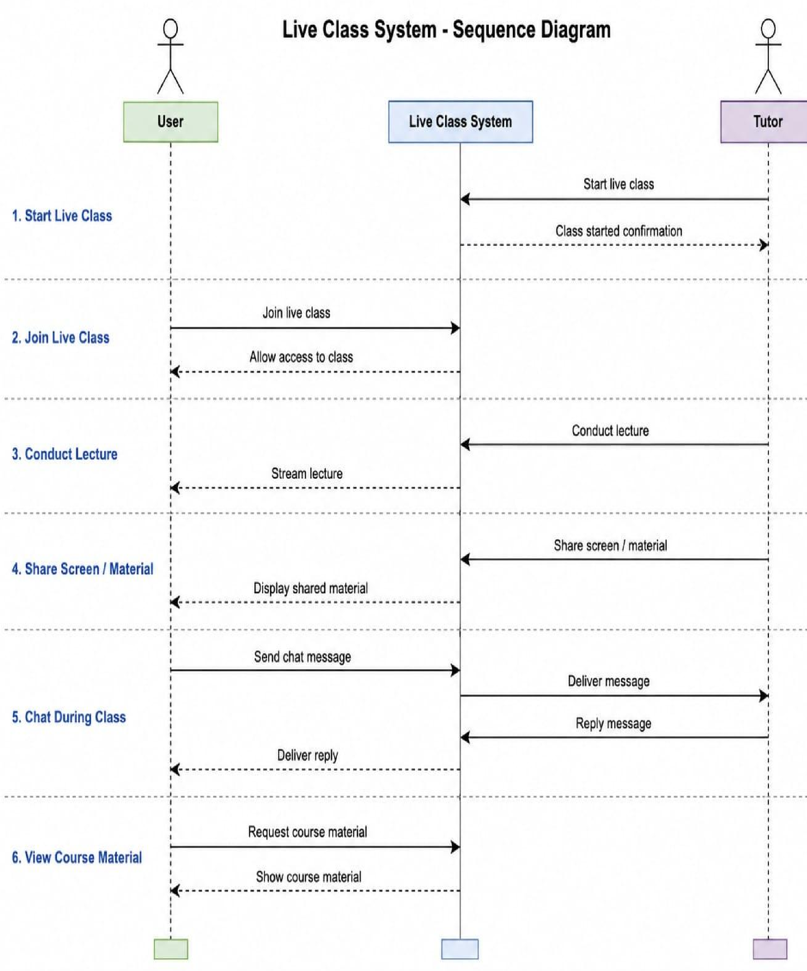
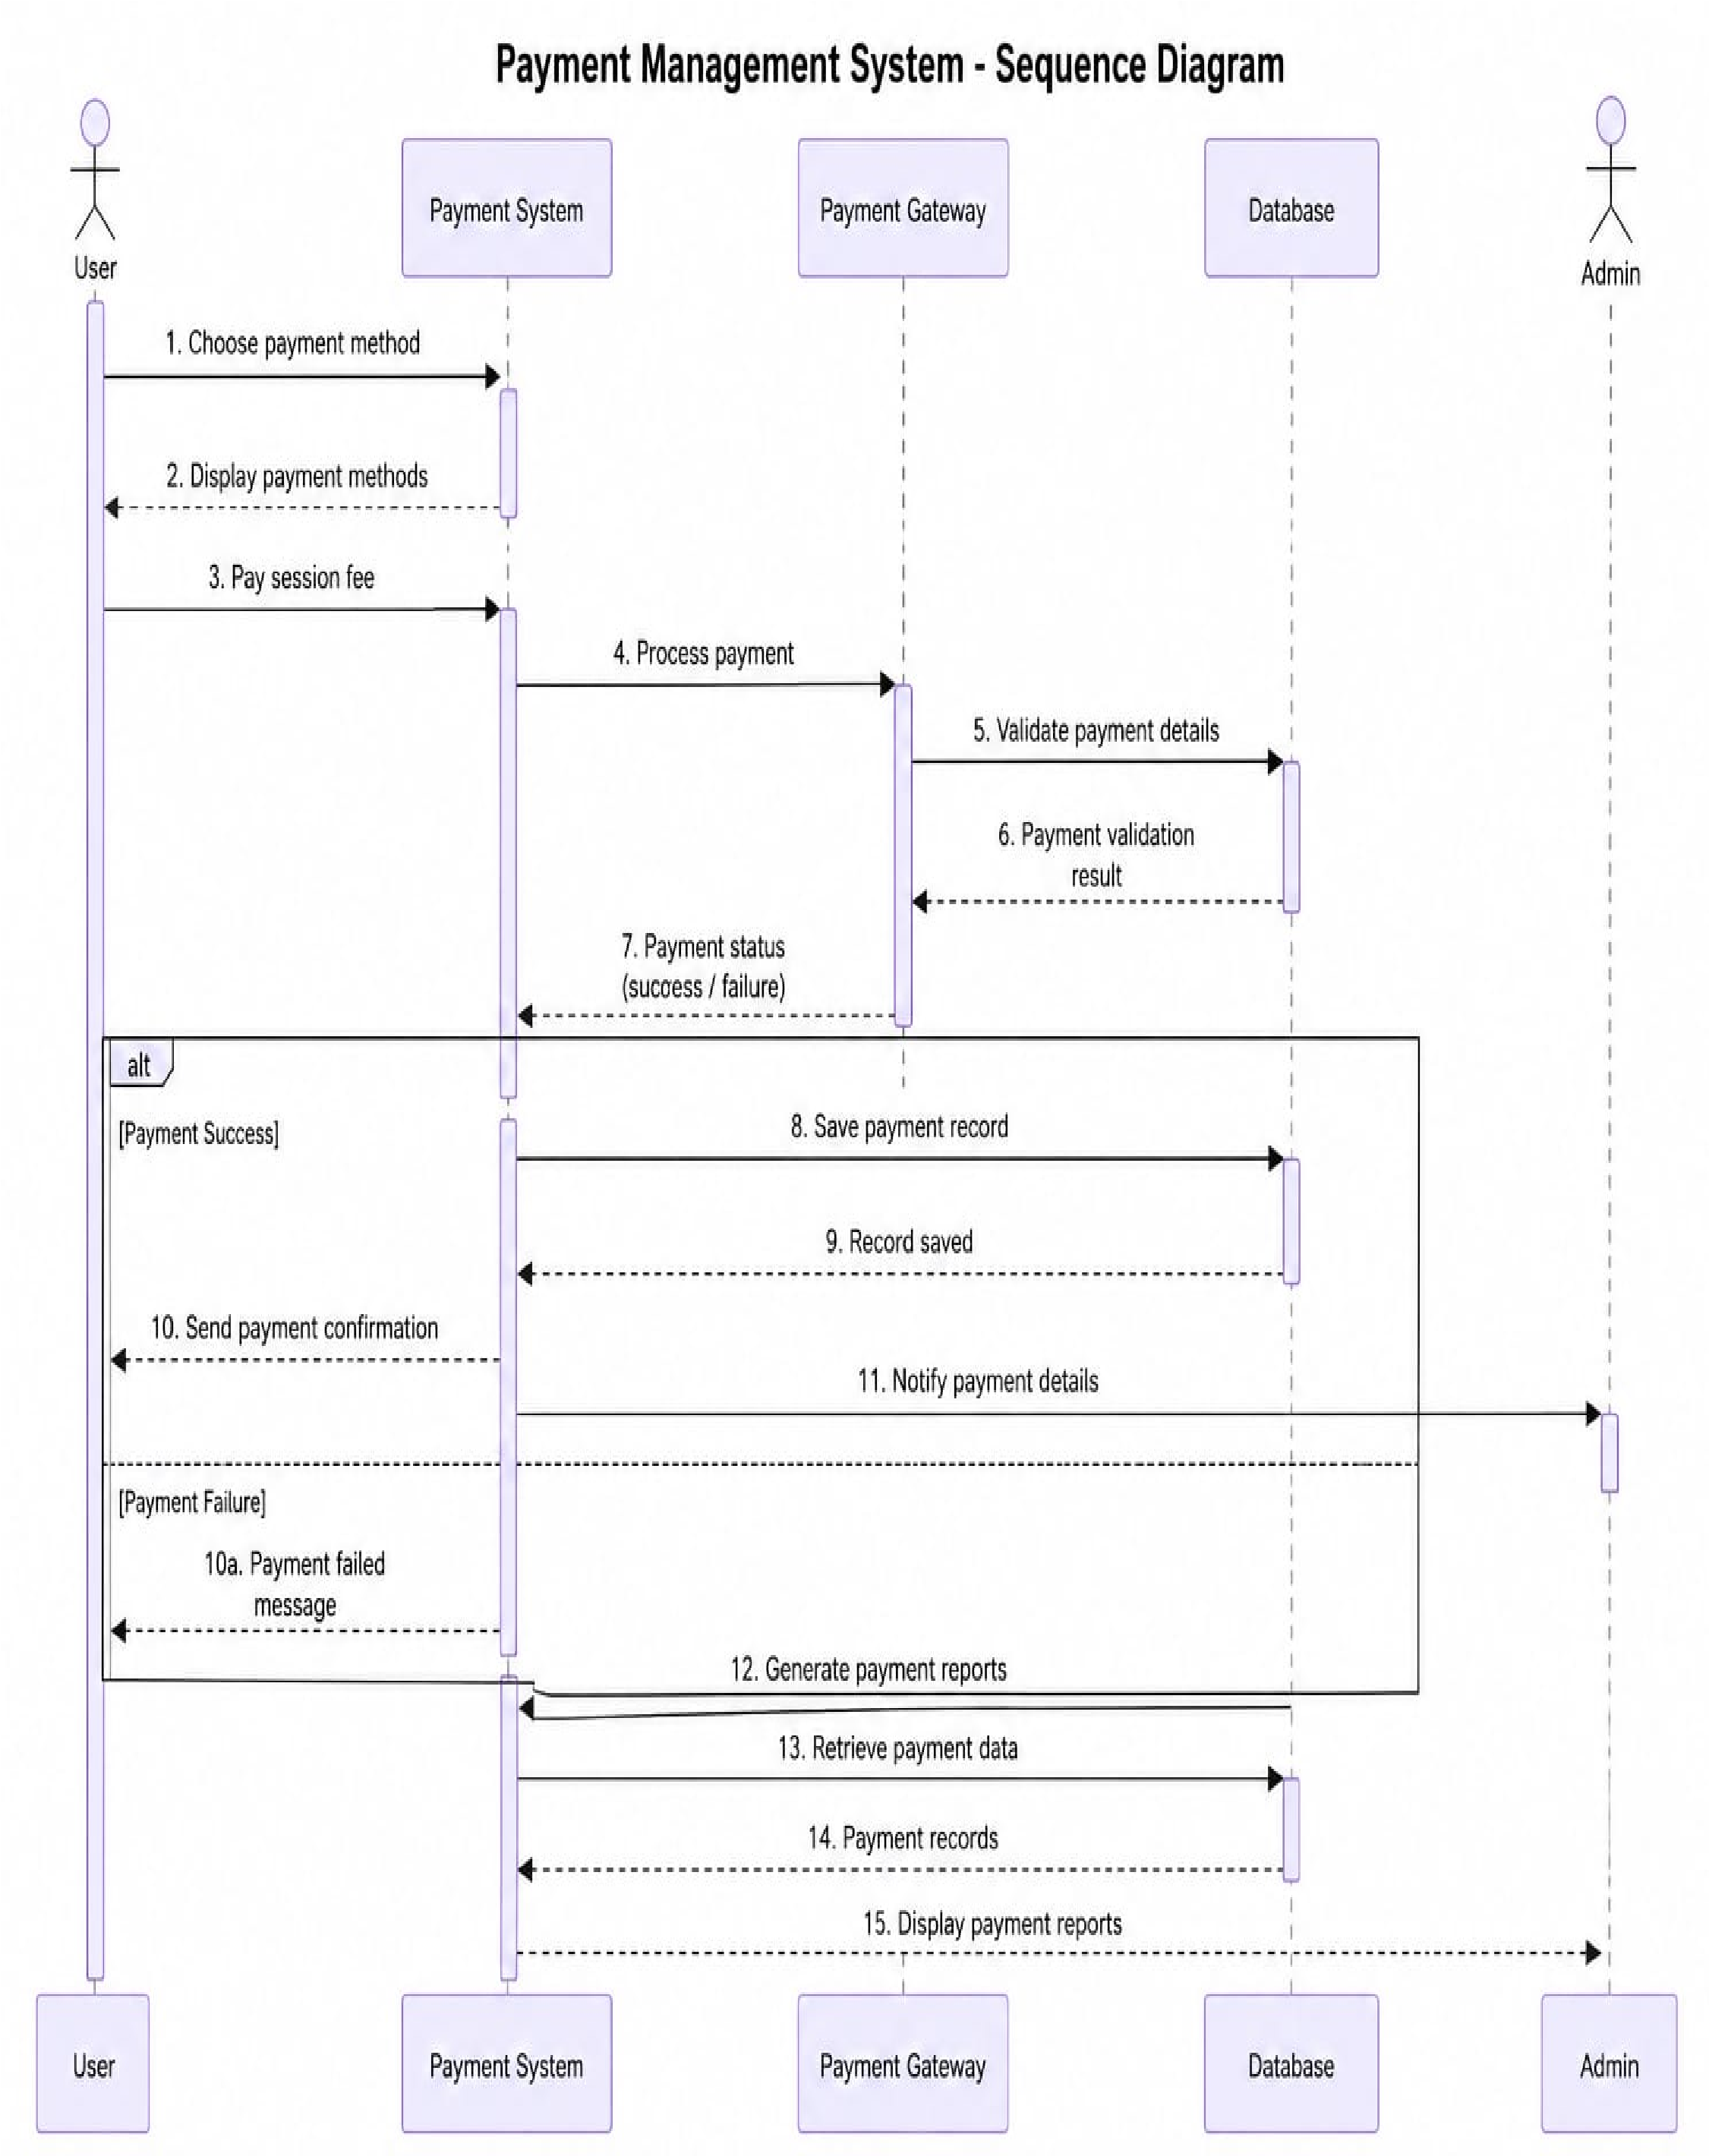
Data Flow Diagrams
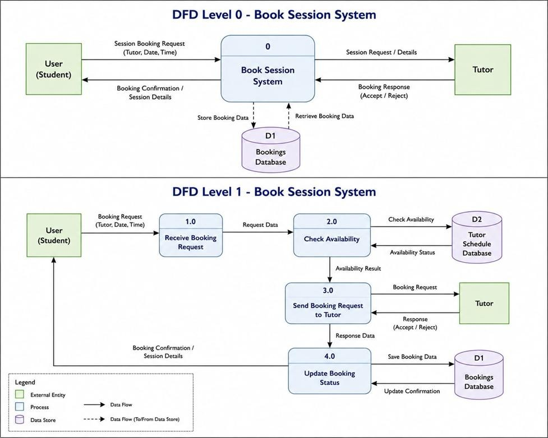
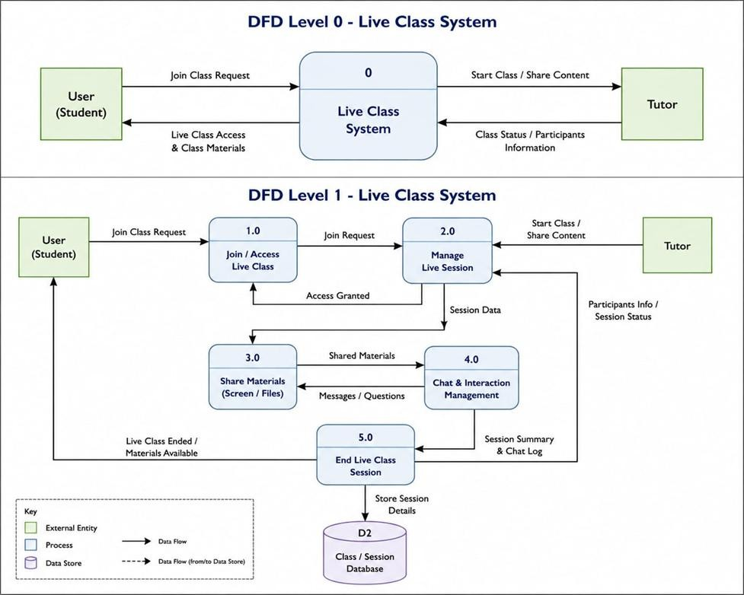
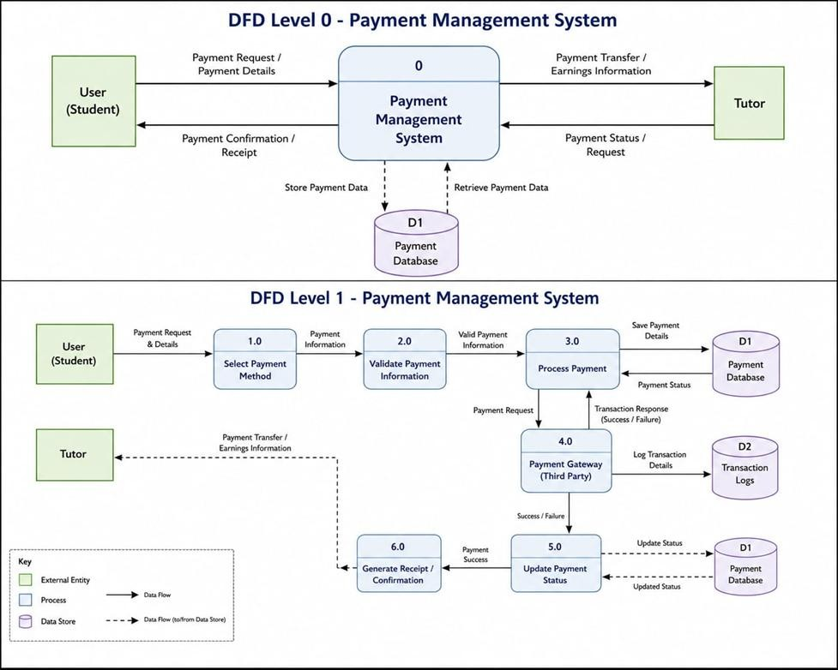

Gantt Chart Flow
